DR Lab Report: Route 53 Failover Implementation
1. Original Objectives
These metrics represent our "success criteria" defined before the lab began.
- Recovery Time Objective (RTO): 30 Minutes
(The maximum acceptable delay to restore service after a failure.)
- Recovery Point Objective (RPO): 5 Minutes
(The maximum acceptable amount of data loss measured in time.)
- The strategy we chose was Backup & Restore.
2. Measured Results
These figures were recorded during the live simulation of a primary region failure.
- Failover Time: 3 Minutes
(Measured from the moment the primary instance was stopped until the DNS resolved to the secondary IP.)
- Restore Time: 15 Minutes
(Measured from the initiation of the "failback" until the primary environment was fully operational and receiving traffic again.)
- Data Loss Window: 4 Minutes
(The gap between the last recorded data backup/sync and the timestamp of the failure.)
3. Conclusion & Performance Analysis
- RTO Evaluation: PASS. The measured failover (3 min) and full restoration (15 min) both fell well within the 30-minute limit.
- RPO Evaluation: PASS. The 4-minute data loss window is within the 5-minute threshold.
Optimization Recommendations:
- Reduce DNS TTL: Lowering the TTL from 300s to 60s or 10s would further decrease the "Failover Time" by ensuring clients clear their cache faster.
- Aggressive Health Checks: Reducing the FailureThreshold from 3 to 2 would allow Route 53 to detect the outage approximately 30 seconds sooner.

Screenshots.
- Route 53 Health Check Console: A shot showing the "Unhealthy" status in red once you shut down the primary server.
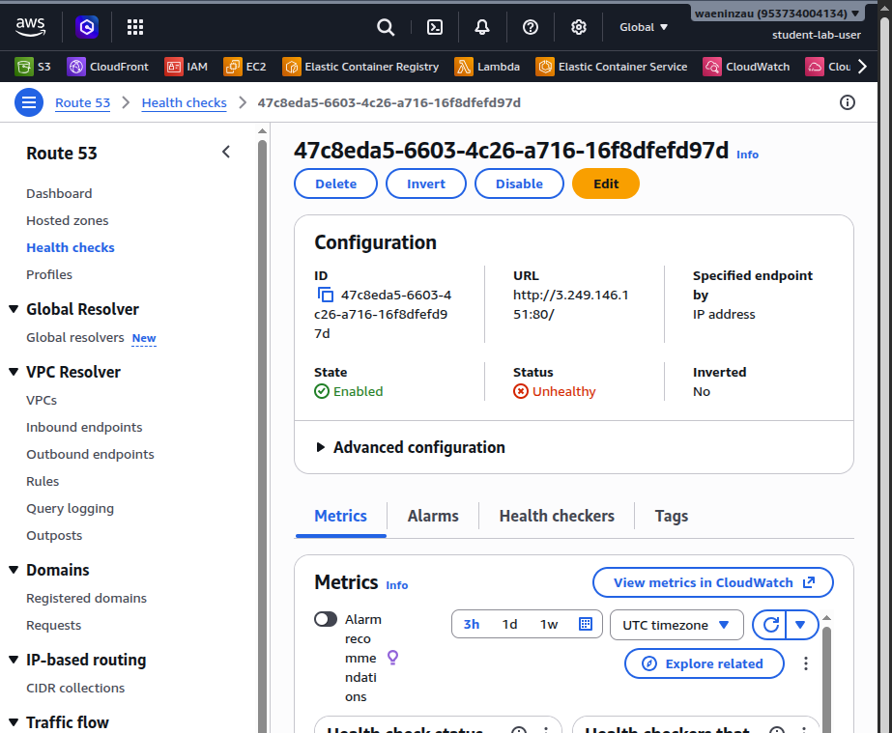
- Health Check Configuration: A screenshot of your health-check.json settings (specifically the FailureThreshold and RequestInterval).
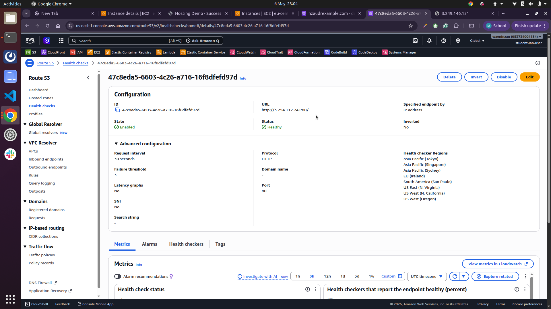
- The Terminal "Switch": Use nslookup or dig showing the primary IP, then a second command showing the secondary IP after the failover.
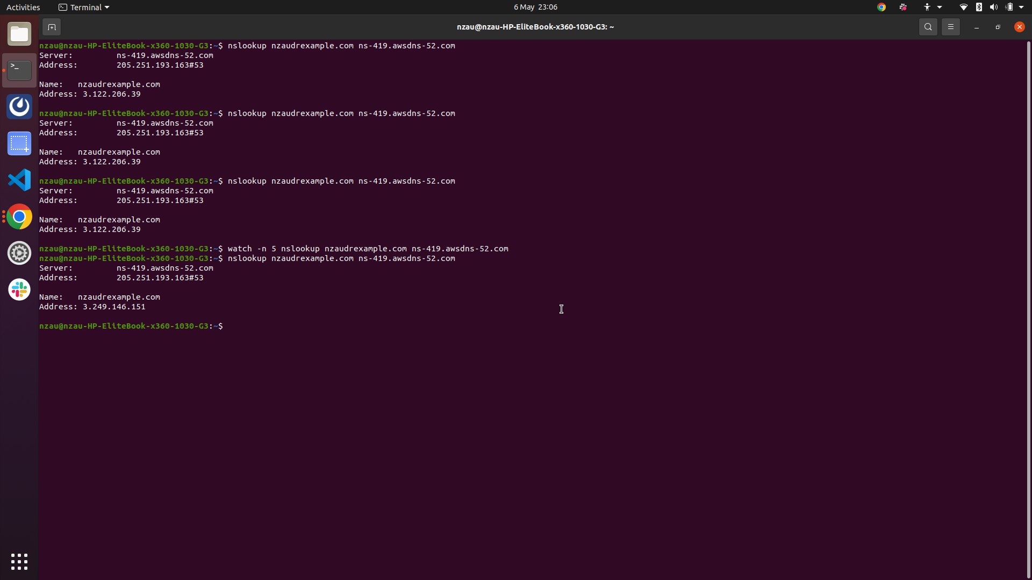
- Failover Policy Record: A view of your Route 53 Hosted Zone showing both the Primary and Secondary records with their respective "Failover" routing policies.
